

**Crypto Beacon: Android Crypto Guide - Illuminating Crypto Frontiers**

PROJECT WORK SUBMITTED TO PSGR KRISHNAMMAL COLLEGE FOR WOMEN

IN PARTIAL FULFILLMENT OF THE REQUIREMENT FOR THE AWARD OF THE

DEGREE OF

BACHELOR OF INFORMATION TECHNOLOGY

**SUBMITTED**

**BY**

**SRI RAGHAVARDHINI.M (21BIT101)**

**GUIDED**

**BY**

**DR. S. BEULA PRINCY., M.Sc., Ph.D.,**

Assistant Professor, Department of Information Technology,

PSGR Krishnammal College for Women,

Coimbatore-641004

**MARCH-2024**

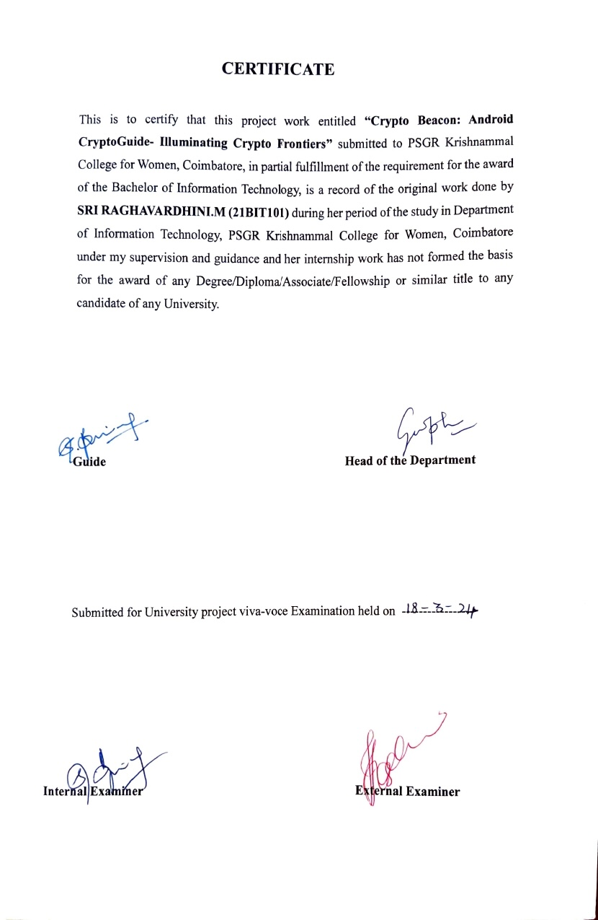

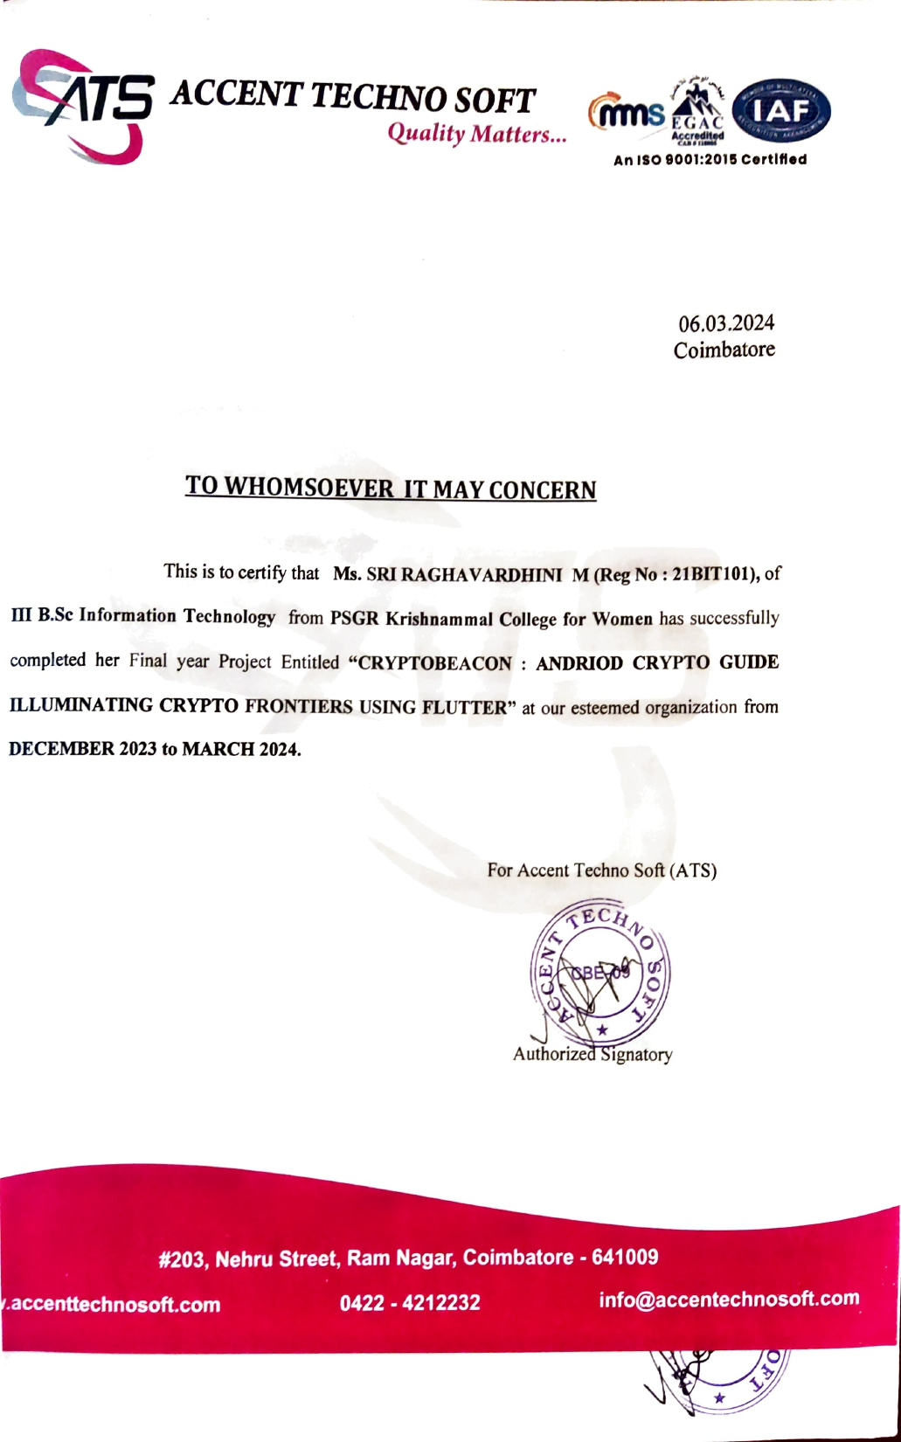

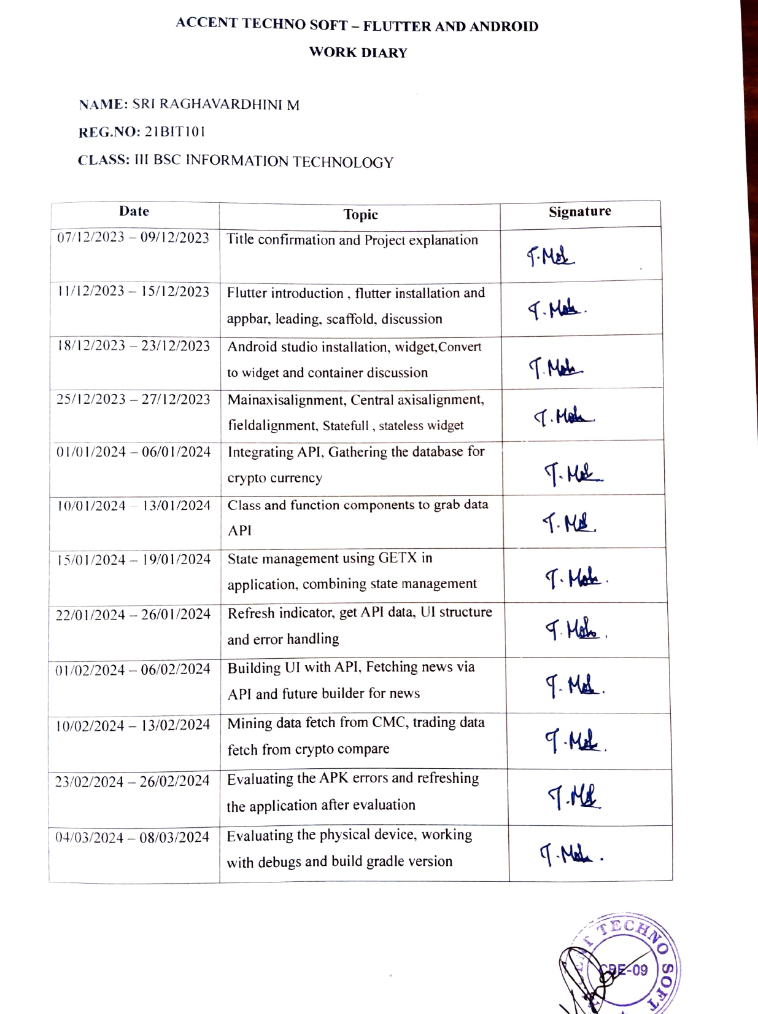



|  |  |  |
| --- | --- | --- |
|  | **TABLE OF CONTENTS** |  |
|  |  |  |
| **S.NO** | **TITLE** | **PAGE.NO** |
|  |  |  |
|  | **ACKNOWLEDGEMENT** | **i** |
|  |  |  |
|  | **ABSTRACT** | **ii** |
|  |  |  |
| **1** | **INTRODUCTION** | **1** |
|  |  |  |
| **2** | **EXISTING SYSTEM** | **2** |
|  |  |  |
| **3** | **PROPOSED SYSTEM** | **3** |
|  |  |  |
| **4** | **SYSTEM REQUIREMENTS** | **4** |
|  |  |  |
| **5** | **SOFTWARE DESCRIPTION** | **5** |
|  |  |  |
| **6** | **CRYPTO COMPARE AND COIN MARKETCAP API** | **11** |
|  |  |  |
| **7** | **PROJECT DESCRIPTION** | **12** |
|  |  |  |
| **8** | **DATA FLOW DIAGRAM** | **13** |
|  |  |  |
| **9** | **DESIGN PHASE** | **15** |
|  |  |  |
| **10** | **INTERFACE DESCRIPTION** | **18** |
|  |  |  |
| **11** | **FUNCTIONAL DESCRIPTION** | **19** |
|  |  |  |
|  | **OUTPUTDESIGN** | **22** |
|  |  |  |
| **12** | **CONCLUTION** | **29** |
|  |  |  |
|  | **FUTURE ENHANCEMENT** | **iii** |

**ACKNOWLEDGEMNT**

I take this opportunity with great pleasure, deep satisfaction and gratitude, the contribute

of many individuals in the successful completion of the system study

I express my hearty gratitude to **Dr(smt). R. NANDHINI,** Chairperson, PSGR Krishnammal College for Women and Coimbatore for having giving us the opportunity to undertake this project.

I express my hearty gratitude to **Dr. N.YESODHA DEVI.,** M.Com., Ph.D., Secretary,PSGR Krishnammal College for Women, and Coimbatore for having given us the opportunity to undertake this project.

I express my gratitude to **Dr. P.MEENA.,** Msc., M.Phil., Ph.D., Principal, PSGR Krishnammal College for Women, Coimbatore for her support and all resource provided.

I am extremely grateful to **Dr. G.SOPHIA REENA.,** MCA., M.Phil., Ph. D., Head of Department, Department of Information Technology, PSGR Krishnammal College for Women, Coimbatore for her sustained interest and advices for the completion of this project.

I also express my heartful thanks to **DR. S. BEULA PRINCY., M.Sc,Ph.D.,** Assistant Professor, Department of Information Technology, PSGR Krishnammal College for Women, Coimbatore as a guide for her kind and patient guidance for completing this project.

I also express my special thanks to  **ACCENT TECHNO SOFT (ATS),** Coimbatore for providing us an opportunity to undertake this project in theiresteemed organization's continuous support to complete the project successfully.

I would like to express my gratitude to my parents and all my friends for their continuous support to complete the project successfully.

**ABSTRACT**

This project introduces a robust cryptocurrency mobile application developed using the Flutter framework, aimed at providing users with a comprehensive and dynamic experience in the world of digital currencies. By seamlessly integrating the CryptoCompare API, the application ensures real-time access to a plethora of cryptocurrency data, ranging from live currency rates and market capitalization to detailed mining statistics, enabling users to make informed investment decisions. The incorporation of the CryptoCompare API also facilitates the retrieval of the latest news articles related to cryptocurrencies, ensuring users stay abreast of market trends, regulatory changes, and emerging technologies.

To enhance user engagement and data personalization, the application integrates SQLite as a local database. This allows users to securely store preferences, such as favourite cryptocurrencies and customized settings, fostering a tailored user experience. The user interface is designed with Flutter's capabilities to provide an intuitive and visually appealing platform, featuring interactive charts and graphs for a holistic understanding of cryptocurrency market dynamics. In essence, this Flutter application amalgamates real-time data retrieval, secure local data storage, and an engaging interface to deliver a sophisticated tool for cryptocurrency enthusiasts and investors alike.

**1.INTRODUCTION**

In response to the escalating demand for intuitive and comprehensive tools in the cryptocurrency domain, this project unveils a cutting-edge mobile application developed using the Flutter framework. The application's central objective is to empower users with real-time insights into the dynamic world of cryptocurrencies, offering a multifaceted approach to data access and personalization. By seamlessly integrating the Crypto Compare API, the application harnesses a wealth of information, providing users with live updates on currency rates, market trends, and mining statistics. This not only facilitates informed decision-making for investors but also ensures that enthusiasts stay well-informed about the rapidly evolving cryptocurrency landscape.

An integral facet of this project lies in its use of SQLite as a local database, ensuring the secure and personalized storage of user data. This strategic integration enables users to tailor their experience by saving preferences, such as favourite cryptocurrencies and customized settings. Through an aesthetically pleasing and user-friendly interface crafted with Flutter, the application aims to deliver an immersive experience, complete with interactive charts and graphs. This amalgamation of real-time data retrieval, secure local data storage, and an engaging interface positions the Flutter application as a versatile and indispensable tool for individuals navigating the complexities of the cryptocurrency market.

**2.EXISTING SYSTEM**

The existing system in the cryptocurrency domain often lacks a unified and user-friendly platform for accessing real-time data, especially when catering to users in specific regions such as India. Currently, users face challenges in obtaining accurate and timely information on cryptocurrency prices, mining statistics, and related news, with limited options for personalizing their experience. Existing applications may lack a seamless integration of diverse functionalities and may not offer a secure and convenient means for users to store their preferences and historical data.

**2.1-Fragmented Data Sources**

* Existing systems often rely on multiple sources for cryptocurrency data, leading to fragmentation and potential discrepancies in information.
* Users may need to navigate between various platforms to access real-time currency rates, mining statistics, and news, making the user experience less cohesive.

**2.2-Global Focus, Local Disconnect**

* Current systems often prioritize global perspectives, resulting in a lack of emphasis on the representation of cryptocurrency values in local currencies, including Indian Rupees (INR).
* Indian users may struggle to interpret and relate to international currency values, hindering their ability to make informed decisions based on local context.

**2.3-Limited Focus on Mining Statistics**

* Existing systems may not comprehensively cover mining statistics, such as hash rates, block rewards, and mining difficulty, leaving enthusiasts with limited insights into this aspect of the cryptocurrency ecosystem.

**2.4-Inadequate News Integration**

* Integration of cryptocurrency-related news may be insufficient or less prominent in the current systems, impacting users' ability to stay updated on market trends and developments.

**3.PROPOSED SYSTEM**

**3.1-Unified Data Integration**

* Implement a robust data integration strategy that consolidates information from various sources, ensuring real-time and accurate data on cryptocurrency prices, mining statistics, and news within a single platform.

**3.2-Localization and Currency Conversion**

* Integrate localization features to represent cryptocurrency values in the local currency, particularly Indian Rupees (INR), providing users with a more relatable and contextually relevant experience.

**3.3-Enhanced Security Measures**

* Implement robust security protocols to safeguard user data, including encryption techniques for storing sensitive information locally in the SQLite database, ensuring user trust and privacy.

**3.4-Focused Mining Statistics**

* Incorporate comprehensive mining statistics, including hash rates, block rewards, and mining difficulty, offering enthusiasts valuable insights into the mining aspect of the cryptocurrency ecosystem.

**3.5-Prominent News Integration**

* Strengthen news integration by prominently featuring cryptocurrency-related news within the application, ensuring users stay informed about market trends, regulatory changes, and technological advancements.

**4.SYSTEM REQUIREMENTS**

**4.1-Hardware Requirements**

Processor : Intel(R) Core(TM) i5-6500T CPU @ 2.50GH

Installed memory (RAM) : 8 GB

Hard Disk : 160 GB

Operating System : Windows 10

**4.2-Software Requirements**

Front-End : Flutter

Back-End : Crypto Compare API, Coin Market Cap API

Tool : Android Studio, Visual Studio Code

Database : SQLite

**5.SOFTWARE DESCRIPTION**

**5.1-Front End**

Flutter is an open-source UI (User Interface) software development framework created by Google. It is designed for building natively compiled applications for mobile, web, and desktop from a single codebase. Flutter was first introduced in 2017 and has gained significant popularity due to its unique approach to creating user interfaces and its ability to provide a consistent experience across different platforms.

Cross-Platform Development Flutter is a powerful framework for building cross-platform applications, meaning a single codebase can be used to create apps for both iOS and Android platforms. This eliminates the need for separate development teams or codebases for each platform, resulting in significant time and cost savings. Widgets and UI Components Flutter’s core building blocks are widgets, which are used to create the user interface (UI) of the app. Flutter provides an extensive library of pre-designed widgets for various UI elements such as buttons, text inputs, images, lists, and more. These widgets are highly customizable, enabling developers to create consistent and visually appealing interface.

Responsive Design Flutter encourages the use of a responsive design approach. Widgets automatically adjust to different screen sizes and orientations, ensuring a consistent and pleasant user experience across various devices, including smartphones and tablets

.

**5.2-Features**

**Handset Layouts:** The platform is adaptable to larger, VGA, 2D graphics library, 3D graphic library based on OpenGL ES 2.0 specification, and traditional smartphone layouts.

**Storage:** SQLite, a lightweight relational database, is used for data storage purposes.

**Connectivity:** Android supports connectivity technologies including GSM/EDGE, IDEN, CDMA, EV-DO, UMTS, and Bluetooth.

**Messaging:** SMS and MMS are available forms of messaging, including threaded text messaging and now Android Cloud To Device Messaging (C2DM) is also a part of Android push messaging service.z

**Web Browser:** The web browser available in Android is based on the open-source Web kit layout engine, coupled with Chrome’s V8 JavaScript engine. The browser scores 100/100 on the Acid3 test on Android 4.0.

**Additional Hardware:** Android can use video/still cameras, touch screens, GPS, accelerometers, gyroscopes, barometers, magnetometers, dedicated gaming controls, proximity and pressure sensors, thermometers, accelerator 2D bit blots (with hardware orientation, scaling, pixel format conversion) and accelerated 3d graphics.

**Multi-Touch:** Android has native support for multi-touch which was initially made available in handsets such as the HTC Hero. The features were originally disabled at the kernel level(possibly to avoid infringing Apple’s patents on touchscreen technology at the time). Google has since released an update for the Nexus One and the Motorola Droid which enables multi-touch natively.

**Applications:** Applications are usually developed in the Java language using the Android Software Development Kit, but other development tools are available, including a Native Development Kit for applications or extensions in C or C++, Google App Inventor, a visual environment for novice programmers and various Cross-platform mobile web applications frameworks.

**Google Play (Android Market):** Android devices. An application program (“app”) called “Market” is preinstalled on most Android devices and allows users to browse and download apps published by third-party developers, hosted on Android Market. As of October 2011 there were more than 300,000 apps available for Android, and the estimated number of applications downloaded from the Android Market as of December 2011 exceeded 10 billion. The operating system itself is installed on 130 million total devices.

**Security:** Android applications run in a sandbox, an isolated area of the operating system that does not have access to the rest of the system’s resources, unless access permissions are granted by the user when the application is installed. Before installing an application, the Play Store displays all required permissions. A gain may need to enable vibration, for example, but should not need to read messages or access the phone book. After reviewing these permissions, the user can decide whether to install the application.

**5.3-Different Dart Files Used In Android Studio**

Flutter Widgets Files (.dart): These Dart files define the various widgets that make up your app’s user interface. Widgets are reusable building blocks, and each Dart file can define multiple widgets. Common widgets include StatefulWidget, StatelessWidget, and custom widgets you create. Main Dart File (main. dart): This is the entry point of your Flutter app. It’s where the void main() function is located, and it’s responsible for running your app. Widget Tests Files (widget_test.dart): Flutter encourages testing, and widget tests allow you to test the behavior and rendering of your widgets. These test files are usually named with a _test. dart suffix and are located in the test folder.

Asset Files (e.g., images, fonts): Your app might include asset files like images, fonts, or configuration files. These files are placed in the assets directory and are referenced in your pubspec.yaml file.

Pubspec File (pubspec. yaml): This YAML file defines your app metadata, dependencies, assets, and other settings. You specify external packages and their versions here. Its also where you list assets that your app uses.

iOS and Android Configuration Files: While not specific to Flutter, your Flutter app will include iOS (.plist) and Android (AndroidManifest.xml) configuration files. These files contain platform-specific settings and configurations for your app.

Localization Files (.arb): If you&#39; re implementing internationalization (i18n) and localization for your app, you&#39; ll use .arb files to define translations for different languages. State Management Files: Depending on the state management solution you choose (e.g., Provider, Bloc, MobX), you might have additional files for managing app state and logic. Generated Files: Flutter generates certain files automatically. For example, when you add a new Flutter widget using Android Studio, it generates the corresponding Dart file and updates the entry in the lib/main. dart file.

**5.3.1-Configuration Files**

Your app might use various configuration files for integrating with services like Firebase, API keys, and more. These files are usually named according to the service they are related to Android and iOS Project Files: While not typically interacted with directly in Flutter development, your project will contain Android (android) and iOS (ios) folders, each containing platform-specific code, resources, and configurations.

**5.4-Back End**

**5.4.1-Android SQLite**

SQLite is an open-source relational database i.e. used to perform database operations on Android devices such as storing, manipulating, or retrieving persistent data from the database. It is embedded in Android by default. So, there is no need to perform any database setup or administration task. SQLite is not directly comparable to client/server SQL database engines such as MySQL, Oracle, PostgreSQL, or SQL Server since SQLite is trying to solve a different problem.Client/server SQL database engines strive to implement a shared repository of enterprise data. They emphasize scalability, concurrency, centralization, and control. SQLite strives to provide local data storage for individual applications and devices. SQLite emphasizes economy, efficiency, reliability, independence, and simplicity. SQLite does not compete with client/server databases. SQLite competes with open ().

If many client programs are sending SQL to the same database over a network, then use a client/server database engine instead of SQLite. SQLite will work over a network file system, but because of the latency associated with most network file systems, performance will not be great. Also, file-locking logic is buggy in many network file system implementations (on both UNIX and Windows). If file locking does not work correctly, two or more clients might try to modify the same part of the same database at the same time, resulting in corruption.

**5.4.2-Android –Php/Mysql**

PHP started as a small open-source project that evolved as more and more people found out how useful it was. Rasmus Lerdorf unleashed the first version of PHP way back in 1994. PHP is a recursive acronym for &quot; PHP: Hypertext Preprocessor. PHP is a server-side scripting language that is embedded in HTML. It is used to manage dynamic content, databases, session tracking, and even build entire e-commerce sites. It is integrated with several popular databases, including MySQL, PostgreSQL, Oracle, Sybase, Informix, and Microsoft SQL Server. PHP is pleasingly zippy in its execution, especially when compiled as an Apache module on the UNIX side. The MySQL server, once started, executes even very complex queries with huge result sets in record-setting time and supports a large number of major protocols such as POP3, IMAP, and LDAP. PHP4 added support for Java and distributed object architectures (COM and CORBA), making n-tier development a possibility for the first time. PHP is forgiving and PHP language tries to be as forgiving as possible Syntax is the same as C language.

MYSQL is used as a database at the web server and PHP is used to fetch data from the database. The application will communicate with the PHP page with the necessary parameters and PHP will contact the MYSQL database and will fetch the result and return the results to us.

**6.CRYPTO COMPARE AND COIN MARKETCAP API**

Cryptocurrency has transformed the landscape of digital finance, introducing a decentralized model for transactions and investment. At the heart of this revolution, APIs like CryptoCompare and CoinMarketCap play a pivotal role, serving as the backbone for developers and investors seeking real-time data and insights into the cryptocurrency market.

CryptoCompare is a comprehensive API that offers a wide array of services for tracking and analyzing cryptocurrency data. It provides detailed information on price movements, trading volumes, historical data, and much more for over thousands of cryptocurrencies across multiple exchanges. Developers can leverage CryptoCompare to build feature-rich applications that require real-time and historical crypto market data, including price charting, market analytics, and portfolio tracking features. Its ease of use, combined with an extensive database, makes CryptoCompare a valuable resource for anyone looking to develop applications or perform in-depth analyses of the crypto market.

CoinMarketCap, on the other hand, is renowned for its extensive database and is often considered the go-to source for cryptocurrency market capitalizations, coin prices, and the overall market trends. The CoinMarketCap API allows developers to access real-time price information, market cap rankings, and percentage changes, thereby enabling them to build applications that provide up-to-the-minute data for investors and traders. With its user-friendly interface and comprehensive dataset, CoinMarketCap serves as a critical tool for those looking to make informed decisions in the fast-paced world of cryptocurrency trading.

Integrating these APIs into a cryptocurrency application not only enriches the app with vital data but also enhances the user experience by providing accurate and timely market insights. Whether it's for mining data, fetching the latest news, or analyzing trading patterns, these APIs offer a robust solution for developers aiming to cater to the diverse needs of the crypto community.

As the cryptocurrency market continues to evolve, APIs like CryptoCompare and CoinMarketCap will undoubtedly remain at the forefront, offering valuable data and insights to drive informed decision-making and innovation in the crypto space.

**7.PROJECT DESCRIPTION**

**7.1 System Modules**

The system comprises one major module with its sub-modules as follows:

**7.1.1-User**

**Home Page:** It consists of suggestions where people can go through Crypto Data mining navigation and Card details adding section

**Crypto List Page:** In this page users can view the price, volume, max supply, market dominance, etc. of the Bitcoin with Indian values

**Crypto News Page:** In this page users can have a glance about the latest trending news about crypto coins and if the user wills they can navigate to full document of news while the tap the interesting news.

**Trading Page:** Here user can make a trade decision according to the bearish or bullish of the coins where the full data of the coin is mentioned accordingly.

**Mining Page:** This shows the mining taken to the respective coin and their net hash and value.

**Card Input Page:** For the investment purpose the application has the capability to withhold user card data possible by using SQLite DB.

**8.DATA FLOW DIAGRAM**

A data flow diagram (DFD) is a graphical representation of the “Flow” of data through an information system, modeling its process aspects. A DFD is often used as a preliminary step to create an overview of the system without going into great detail, which can later be elaborated. DFDs can also be used for the visualization of data processing (structured design). A DFD shows what kind of information will be input to and output from the system, how the data will advance through the system, and where the data will stored.

DFD shows how the information moves through the system and how it’s modified by a series of transformations. It is a graphical technique that depicts information flow and the transformations that are applied as data moves from input to output.

The data flow diagram (DFD) is one of the most important modeling tools. It is used to model the system components. These components are the system process, the data used by the process, an external entity that interacts with the system and the information flows in the system.

**8.1.1-DFD DIAGRAMS**

1. **Level 0:**

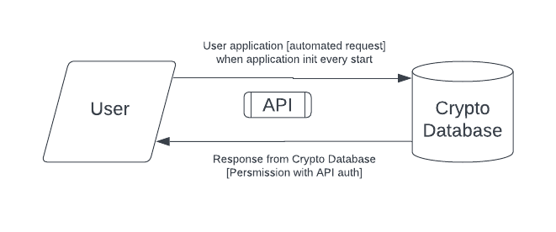

1. **Level 1:**

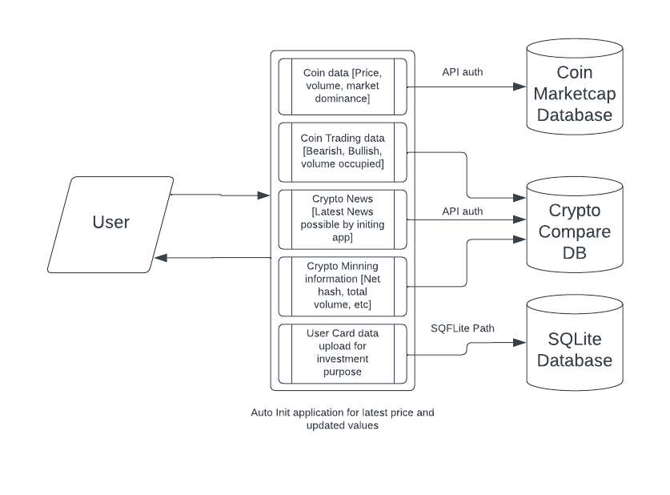

**9.DESIGN PHASE**

* 1. **9.1-Introduction**

The design phase is the period in the software life cycle during which the designs for architecture, software components, interfaces, and data are created, documented, and verified to satisfy requirements.

Details on computer programming language and environments, application packages, layering, memory size, platform, algorithms, data structure, interfaces, and many others. The design may include the usage of existing components. The components are as follows

* Input design
* Output design
* Code design
* Database design

**9.2-Input Design**

Input design is the process of converting an external user-oriented description of the input system into a machine-oriented format. The source document is prepared for the input of data to make the entry accurate and impact the source document was prepared. The data elements were sent out in a system that the data entry operator would easily follow.

* + 1. **9.3-Objectives Of Input Design**

In accuracy, input data is the most common cause of errors in data processing. Errors found at the data entry can be controlled by the proper input design. The input was designed with the following objectives

* To produce a cost-effective method.
* To get the highest level of accuracy.

To ensure that the input is acceptable and understandable by the people who are using it. With the above objectives, the major activities that were done during the input design are:

* The data are collected from its source.
* Data are converted to the mobile acceptable form.
* The converted data was verified.
  1. **9.3-Code Design**
  2. The process of code is to facilitate the identification and retrieval of items of information. The code should be written such that it is simple and easy to understand. The following characteristics were also considered while designing the code.
* Ambiguity
* Uniqueness
* Simplicity
* Stability
* Easy to update

The code should be adequate for present and anticipated data processing for machine and human use.

**9.4-Database Design**

Data is pivotal to any organization's activities. The objectives of the database design are to store the captured data efficiently and to facilitate timely retrieval. Proper attention has to be taken in designing the database.

The database is the heart of any information system any information must be collected, accumulated, edited, and retrieved. Therefore it should directly need files should be properly designed and planned, Files are a crucial component for the successful performance of the system. File design includes master files and transaction files.

**9.5-Output Design**

Output design is a process that involves designing necessary output that has to be given to various users according to their requirements, Efficient, intelligible output design will improve the system's relationship with the user and help indecision-making. Since the reports are directly required by the management to make decisions and to draw conclusions, they must be designed with care for the user. The options for the output and report are given in the system menu. When designing output, system analyst must accomplish the following

* Determine the information to present.
* Arrange the presentation of information acceptable format.
* Determine how to distribute the output.

**9.6-Table Design**

Screen design begins with the recognition that the screen is composed of different areas. Layout tools assist the analyst in specifying the content of the signal and multiple design formats. All screens have been provided with menus, push button facilities, icons, and control buttons. The main screen consists of two buttons which we can move to another screen. In designing output screens we need area for

* Heading and titles.
* The content of the display.
* Message and instructions.
* Sometimes explanations for information in the report.

A database is a collection of data about a specific topic.

**10.INTERFACE DESCRIPTION**

* 1. **10.1-Internal Interface**

A key principle of design is to prohibit access to all resources by default, allowing access only through well-defined entry points, i.e. interfaces. Software interfaces provide access to computer resources (such as memory, CPU, storage, etc.) of the underlying computer system; direct access (i.e. not through well designed interfaces) to such resources by software can have major ramifications sometimes disastrous ones for functionality and stability. Interfaces between software components can provide: constants, data types , types of procedures, exception specification and method signatures. Sometimes, public variables are also defined as part of an interface.

**10.2-External Interface**

Hardware interfaces exist in many of the components such as the various buses, storage devices, other I/O devices, etc. A hardware interface is described by the mechanical, electrical and logical signals at the interface and the protocol for sequencing them (sometimes called signaling). A standard interface, such as SCSI, decouples the design and introduction of computing hardware, such as I/O devices, from the design and introduction of other components of a computing system, thereby allowing users and manufacturer’s great flexibility in the implementation of computing systems.

Hardware interfaces can be parallel with several electrical connections carrying parts of the data simultaneously, or serial where data is sent one bit at a time.

**10.3-User Interface**

The **User Interface** (**UI**), in the industrial design field of human–machine interaction, is the space where interactions between humans and machines occur. The goal of user interaction is to allow effective operation and control of the machine from the human end, whilst the machine simultaneously feeds back information that aids the operators' decision-making process. Examples of the broad concept of user interfaces include the interactive aspects of computer operating systems, hand tools, heavy machinery operator controls, and process controls.

**11.FUNCTIONAL DESCRIPTION**

* + 1. **11.1-Processing Narrative**

Processing narrative deals with the function, which are used to solve the problem in this project. Description of each function is required to solve is presented to the functional description .Processing narrative is provided for each function, design constraints are stated and justified. Performance characteristics will be stated also one more diagrams are includes to represent the overall system structure of software.

**11.2-Restrictions And Limitations**

Restrictions and limitations are nothing but level of work where a user cannot continue further. The login screen is made with the authorization username and password the overall application is only handled by the students and they can login after registration.

* Unauthorized users login are restricted
* Registered users are only eligible to login the system.

**11.3-Performance Requirements**

**Security:** The application is secured it doesn’t provide any way to enter the users other than the authorized user.

**Availability:** Availability is the probability that a program is operating according to requirements at a given point of time. The availability is an indirect measure of the maintenance of the software. The functionality of the program is immediately available once it has been logged in.

**Response Time:** Response time is the time with in which an application identifies the instruction of the customer and response to it. The response time of the application is made efficient and quick so that the requests are accepted according to their validity and the result can be delivered to the customer with an immediate effect.

**11.4-Behavioural Description System Event Anactions**

A state is any observable mode of behaviour member state, element state is two important states represent a mode of behavior of the system. Member state has two states, active and deactivate, normally all members are in de-active state, there corresponding action is member activation. As well as to change active to deactivate state same event of member detail modification should be fired respective action is member de-activation.

The system uses various kinds of events and states. System state represents the action that starts when an event occurred. The system contains the events such as Load, Click, and Selected Index Changed etc.

**Load Event:** Load event is the first event which is focused at the time of execution. Mainly the connection and initialization activities are done under this event.

**Click Event:** The controls like button and hyperlinks has click event as a default event. It helps to accelerator the process.

**Selected Index Changed:** This event is mainly used in the drop down list boxes, list boxes, radio buttons and checkboxes. In these types of events the process are carried out according to the choice selection.

**11.5-Testing And Implementation**

**11.5.1Testing**

System testing is a stage of implementation which is aimed at ensuring that the system works accurately and efficiently . The primary goal of the test process is to make sure that theapplication performs as discussed in the requirement and specifications. Testing begins at the module level and works towards the integration of the entire computer based system.

Testing methodologies:

* Unit Testing
* Widget Testing
* Integration Testing

**11.5.2-Unit Testing**

Unit testing in Flutter involves testing individual units of code, such as functions, methods, or classes, in isolation to ensure they behave as expected. Flutter provides the test package for writing and executing unit tests. The goal is to ensure that each unit of code behaves correctly in isolation. By regularly running unit tests as part of your development workflow, you can catch issues early and maintain a high level of code quality in your Flutter application.

**11.5.3-Widget Testing**

* 1. Widget testing in Flutter involves testing individual widgets and their interactions within a Flutter app. It's a type of testing that focuses on the visual and interactive aspects of your app's user interface. Widget tests are particularly useful for ensuring that your widgets render correctly, respond to user interactions as expected, and maintain their behavior across different app states. By writing and running widget tests regularly, you can catch visual and interactive issues early in the development process and maintain a stable user interface.
  2. **11.5.4-System Implementation**

System Implementation is the stage of the project when the theoretical design is turned into practical system. After proper testing and validation, system implementation should be done. System implementation includes all those activities that take a place to convert an old system to the new system.

**11.5.5-Integration Testing**

* 1. Integration testing in Flutter involves testing the interaction between different components, screens, or widgets of your app to ensure they work together as expected. Integration tests help you ensure that different parts of your app interact correctly and that your app's overall functionality is not compromised as you make changes or add new features. By regularly running integration tests, you can catch issues related to navigation, state management, and widget interactions early in the development process.

**OUTPUTDESIGN**

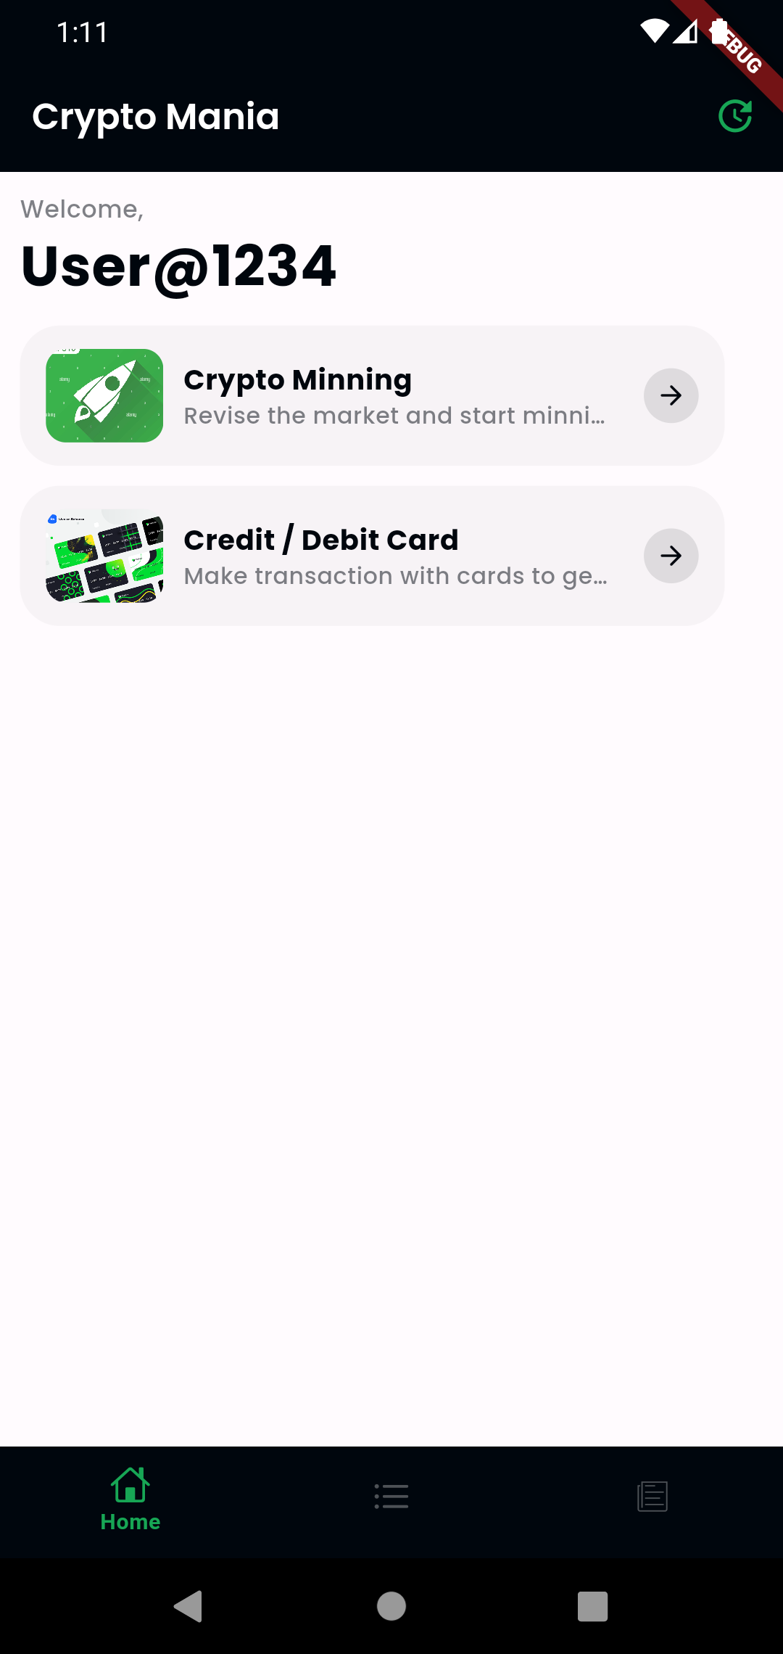

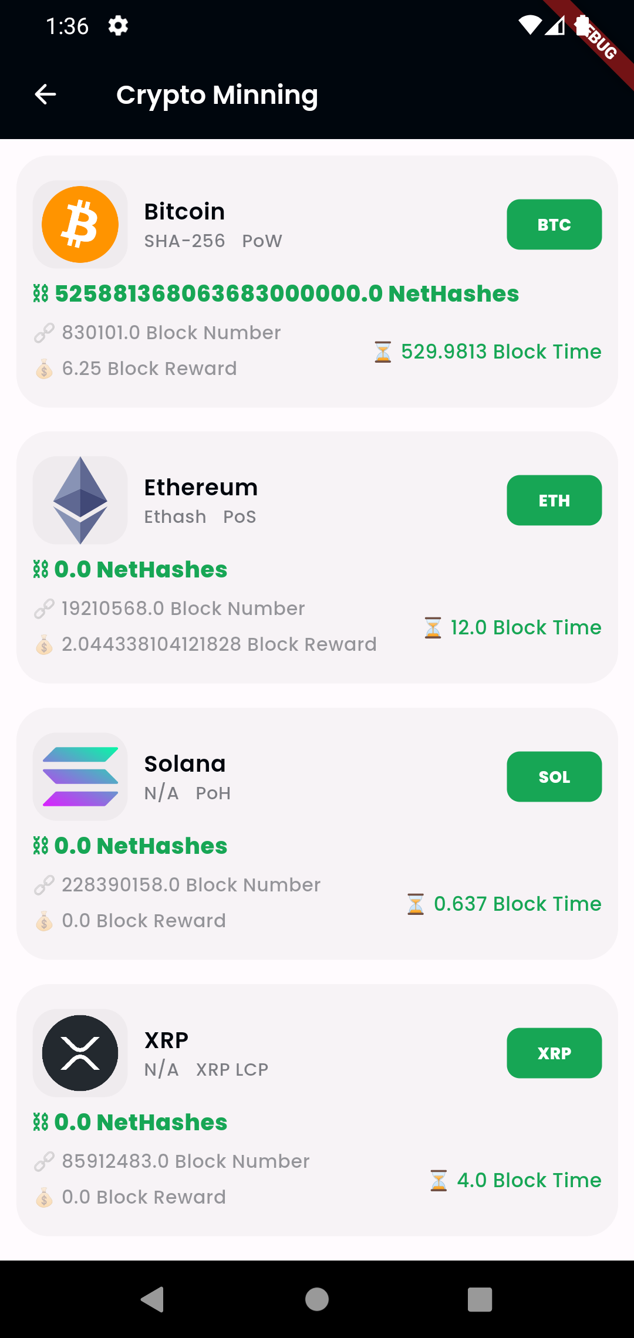

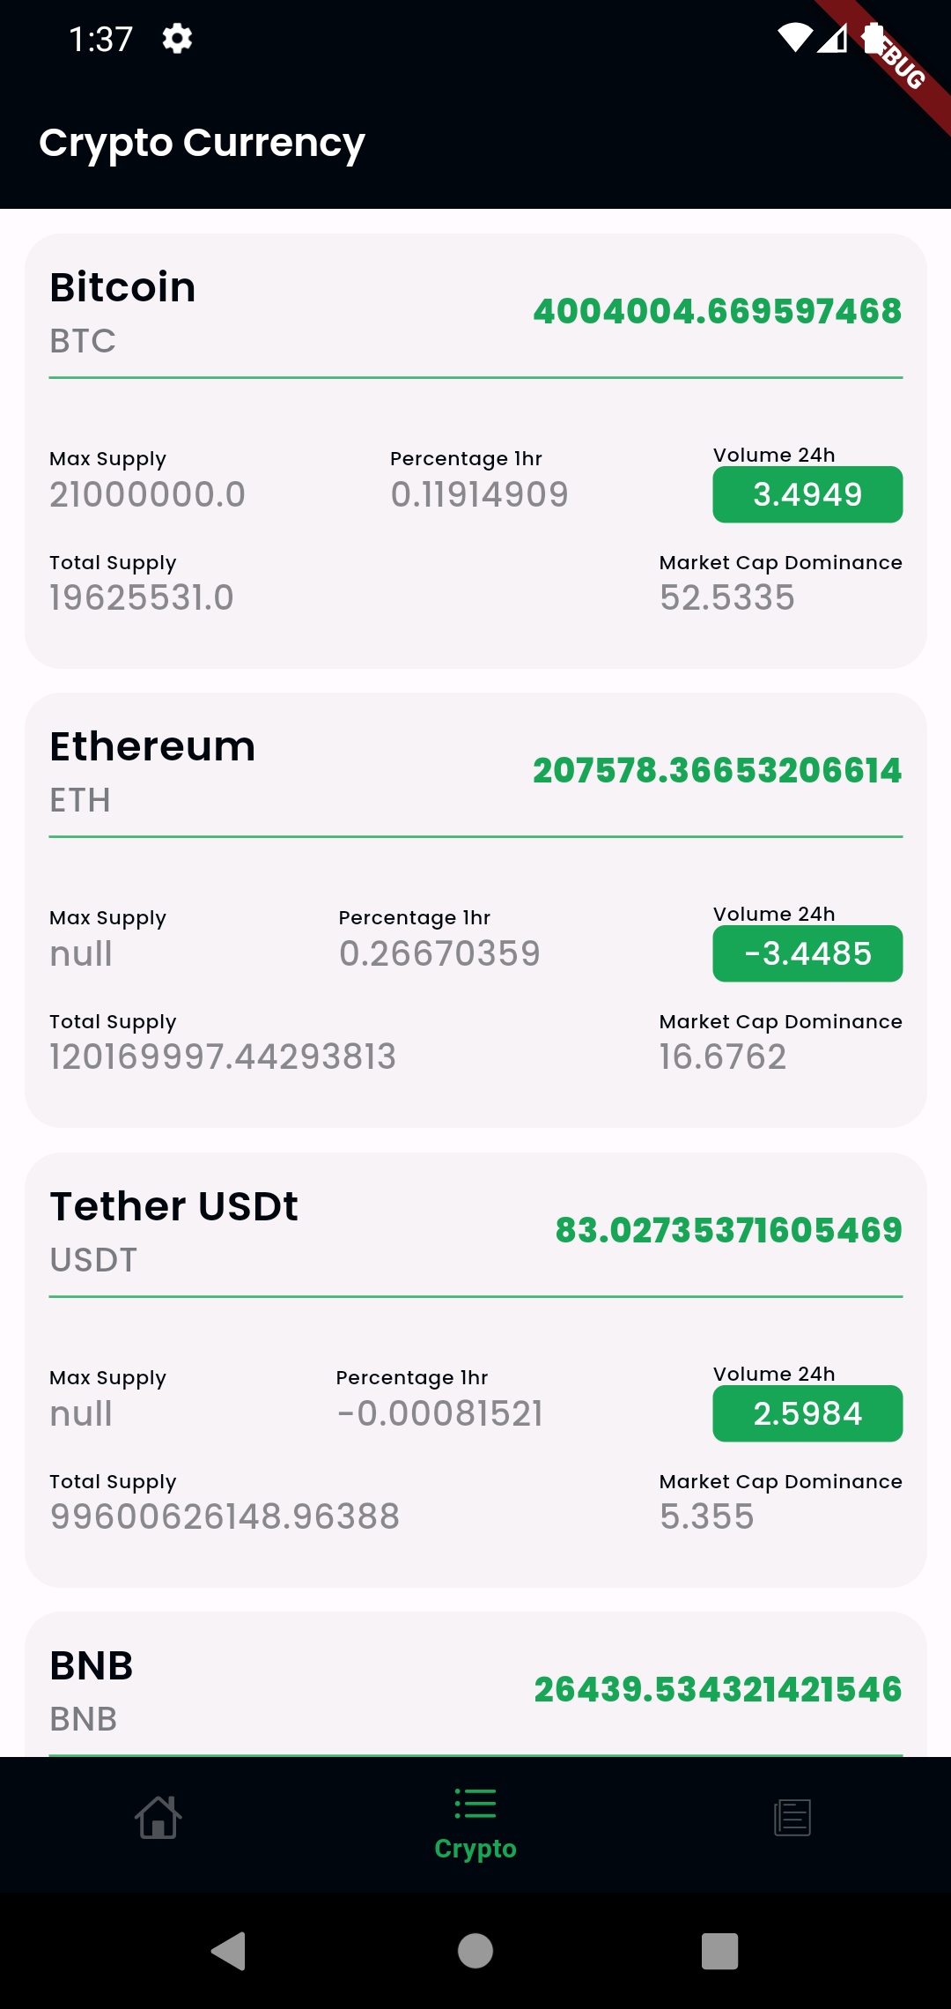

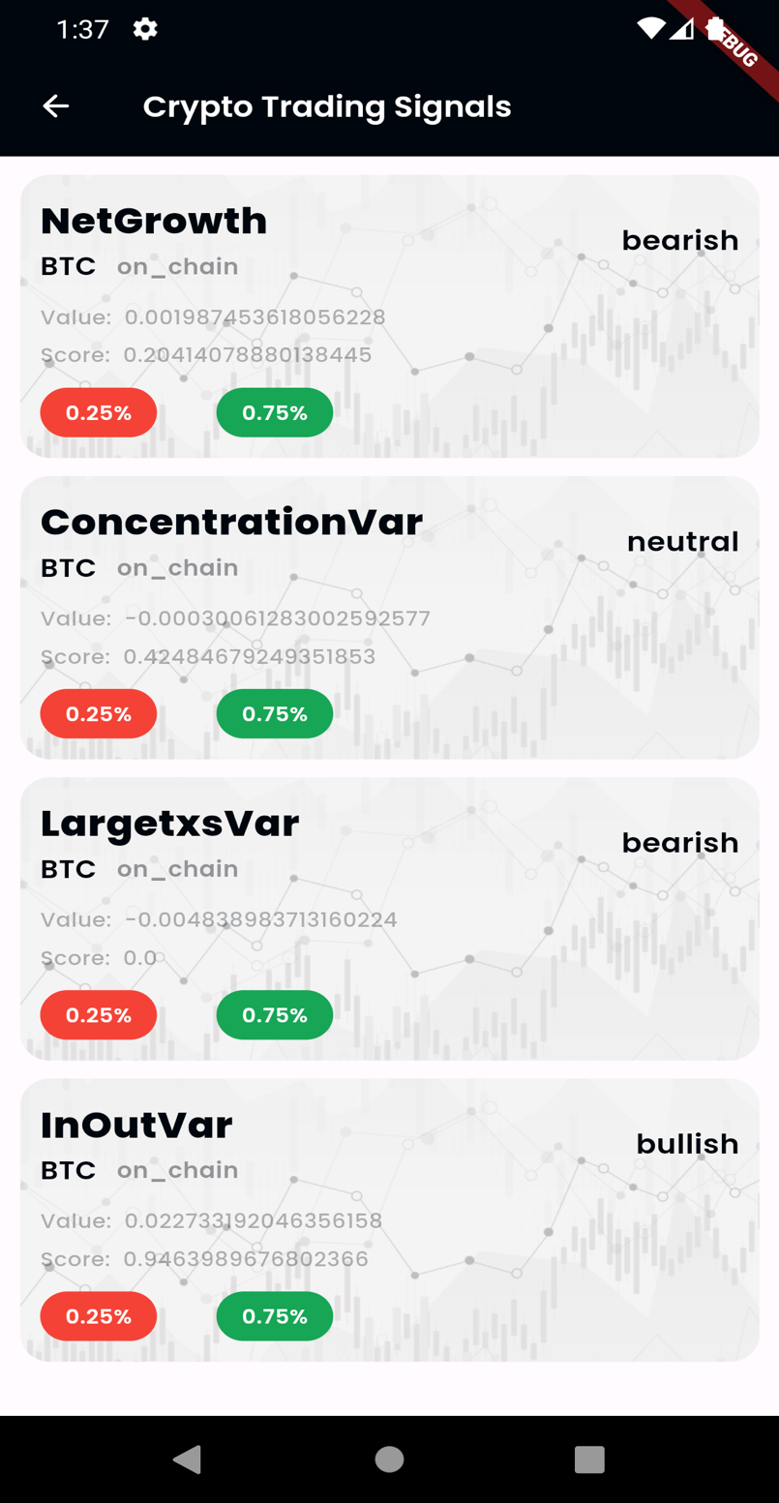

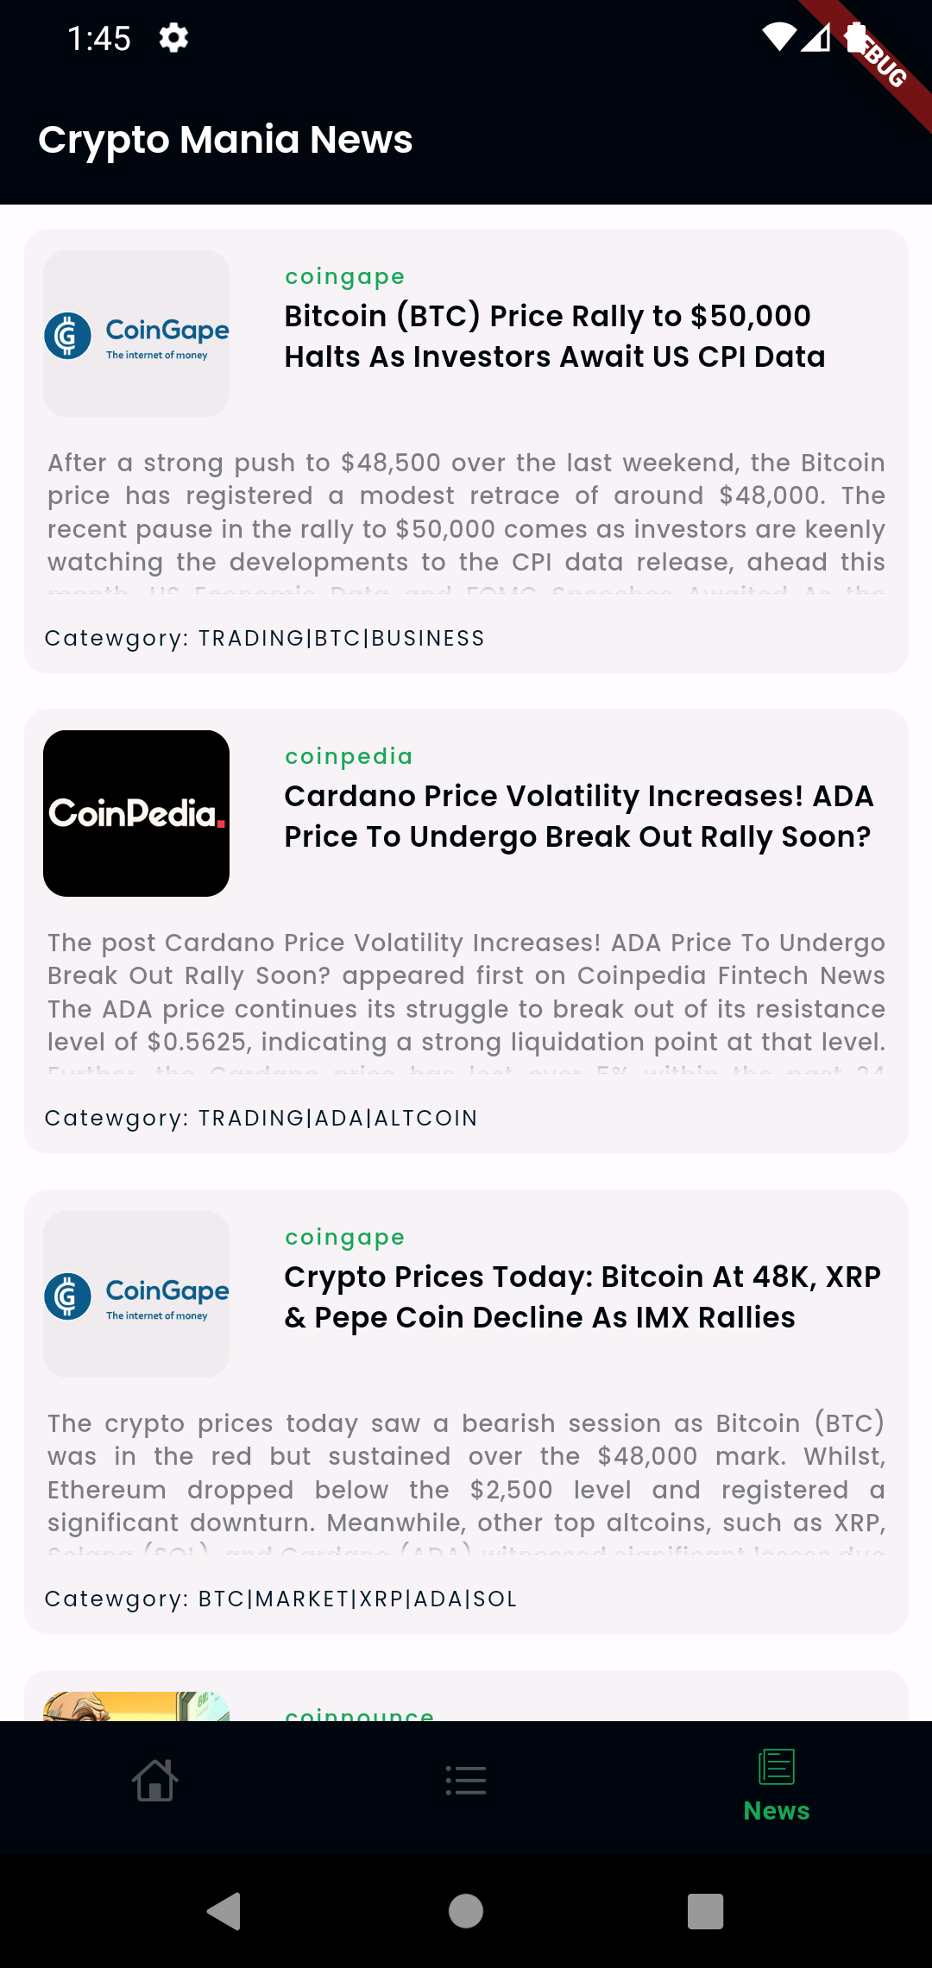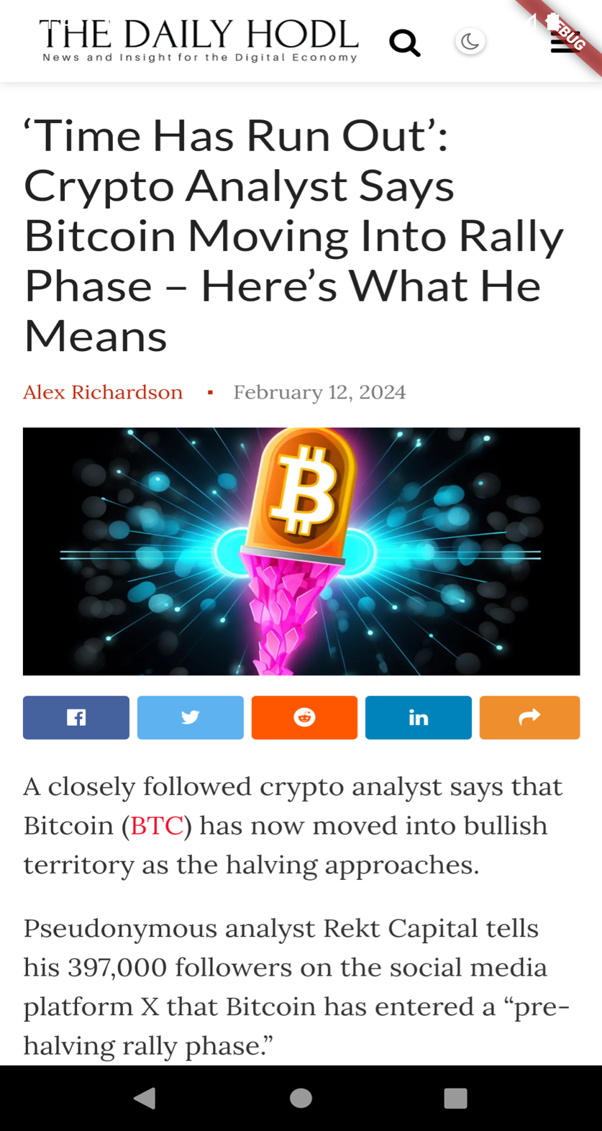

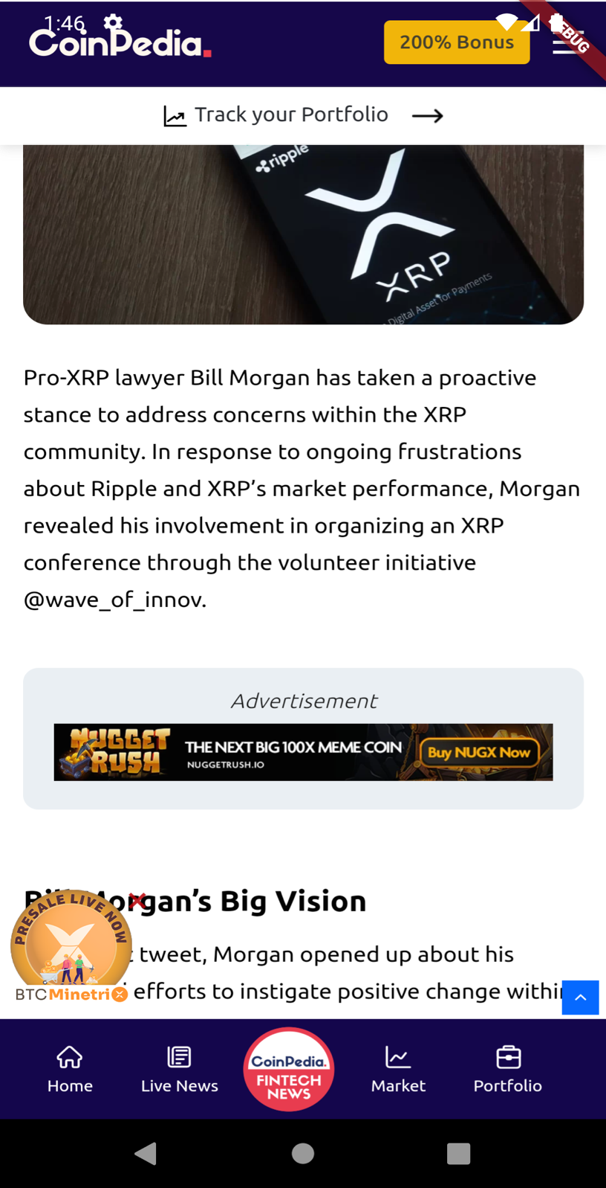

**12.CONCLUTION**

The development of a cryptocurrency application that leverages the robust capabilities of APIs like CryptoCompare and CoinMarketCap represents a significant stride towards making cryptocurrency data more accessible and understandable for a broad audience. By integrating these powerful tools, the application stands as a testament to the potential of modern technology to democratize information and provide users with the insights needed to navigate the complex and volatile world of cryptocurrency. This project not only enhances the user experience by offering real-time data and comprehensive market analysis but also empowers users to make informed decisions with confidence.

In conclusion, this cryptocurrency application serves as a bridge between the intricate cryptocurrency market and individuals seeking to engage with it, whether they are seasoned traders, casual investors, or newcomers curious about the digital currency space. The use of CryptoCompare and CoinMarketCap APIs ensures that the application is equipped with a wealth of information, from detailed coin analyses to global market trends, all presented in a user-friendly format. This approach not only elevates the standard for crypto-related applications but also contributes to the overall growth and maturity of the cryptocurrency ecosystem.

Furthermore, the project underscores the importance of transparency and accessibility in financial technologies. By providing users with reliable and up-to-date information, it fosters a culture of trust and accountability in an industry often criticized for its opacity. Moving forward, the continued evolution of such applications will play a crucial role in shaping the future of finance, making it more inclusive and accessible to individuals around the globe.

Lastly, as the cryptocurrency market continues to evolve, the adaptability and scalability of the application will be paramount. The integration of APIs like CryptoCompare and CoinMarketCap not only provides a solid foundation for current needs but also offers the flexibility to incorporate future advancements in the crypto space. This project, therefore, not only stands as a significant achievement in the present but also paves the way for future innovations, contributing to the ongoing transformation of the digital finance landscape.

**FUTURE ENHANCEMENT**

Looking ahead, the cryptocurrency application built on the robust frameworks provided by CryptoCompare and CoinMarketCap APIs has significant room for future enhancements that could further solidify its position as a leading tool in the digital finance space. One of the key areas for development is the integration of artificial intelligence (AI) and machine learning (ML) algorithms. By leveraging AI, the application could offer predictive analytics, enabling users to gain insights into potential future market movements based on historical data and trends. This could include features like price prediction models, sentiment analysis from various news sources and social media, and automated trading strategies tailored to individual user preferences and risk profiles.

Another avenue for future enhancement is the expansion of the application’s blockchain analytics capabilities. As the blockchain technology landscape evolves, there's a growing need for more sophisticated tools that can analyze blockchain data in real-time. This includes tracking wallet transactions, identifying trends in token distribution, and monitoring smart contract interactions. Enhanced blockchain analytics could provide users with deeper insights into market dynamics, contributing to more informed investment decisions. Additionally, incorporating decentralized finance (DeFi) analytics would cater to the rapidly growing interest in the DeFi sector, offering users visibility into yield farming opportunities, liquidity pools, and DeFi project metrics.